BEE There for IPEI’S 18th Annual SPELLING BEE
Sunday, March 6, 2016, 2:00 p.m.
Ithaca High School Wellness Center Gym

Bee a Part of the BUZZ!
Advertise in the Spelling Bee Event Program

IPEI is seeking advertisers for the event program that will be distributed to all participants and attendees at its 18th Annual Adult Spelling Bee. Income from the ads will go directly to support IPEI’s teacher grants.
To place an ad in the event program, please complete the form below and return it by email with the artwork for your ad attached according to the specifications below. Send to jlangenbacher@ipei.org. Electronic forms are available at www.ipei.org (click on “Events”).
Payment can be made by check written to IPEI for $50, mailed to IPEI, PO Box 4268, Ithaca, NY 14852-4268. Or pay by credit card, please call 607-256-4734; or payment can be made securely on-line at www.ipei.org.
The deadline for receiving your artwork and payment is February 8, 2016.

If you have any questions, call 607-256-4734.

I wish to place an ad in IPEI’s 18th Annual Adult Spelling Bee event program.

Advertiser Name __________________________________________________________

Contact Name _____________________________________________________________

Address_____________________________________________________________

Phone ________________________________Email_________________________

____ Artwork attached as a camera-ready PDF, business-card size (3 ½” w x 2” h)

Please indicate method of payment:
____ Check sent by mail
____ Credit card (call 607-256-4734)
____ Online (www.ipei.org)
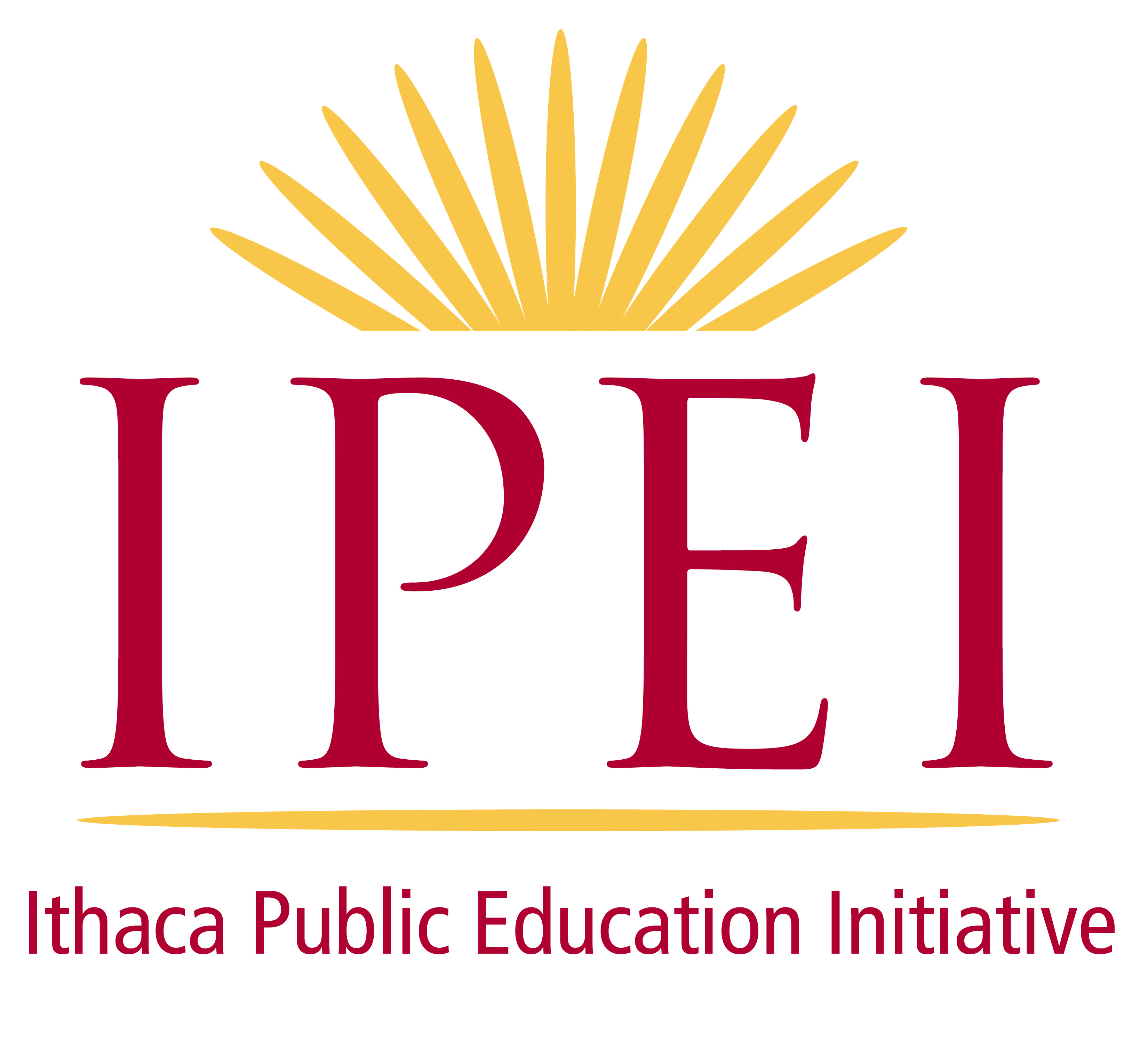
Please Respond by February 8, 2016!
The mission of the Ithaca Public Education Initiative (IPEI) is to facilitate community connections and support for students and teachers of the Ithaca City School District through engagement, collaboration, gifts, and grants. For more information see IPEI.org or contact us at 607-263-IPEI (4734) or ipei@ipei.org.

