BEE There for IPEI’S 18th Annual SPELLING BEE
Sunday, March 6, 2016, 2:00 p.m.
Ithaca High School Wellness Center Gym

Bee a Part of the BUZZ!
Donate an item to the Silent Auction

IPEI is seeking donations for a silent auction that will be held during its 18th Annual Adult Spelling Bee. Income from the auction will go directly to support IPEI’s grants for teachers. As a thank you for your donation to the auction, auction items and donors will be acknowledged in our event program and publicity.
To donate an item to the silent auction, please complete the form below and return it by email to jlangenbacher@ipei.org. This form is also available at www.ipei.org (click on “Events”).
The deadline for form submission for donating an auction item is February 8, 2016. Arrangements can be made for a later pick-up of the item. If you wish to drop off your item, please call 607-256-4734 in advance.

If you have any questions, please also call 607-256-4734.

I wish to donate an auction item and be recognized in the publicity and event program for IPEI’s 18th Annual Adult Spelling Bee.

Business name ___________________________________________________________________

Auction item______________________________________________________________________

Value of In-kind donation___________________________________________________________

Contact name ____________________________________________________________________

Address___________________________________________________________________

Phone ________________________________Email_______________________________

Please Respond by February 8, 2016!

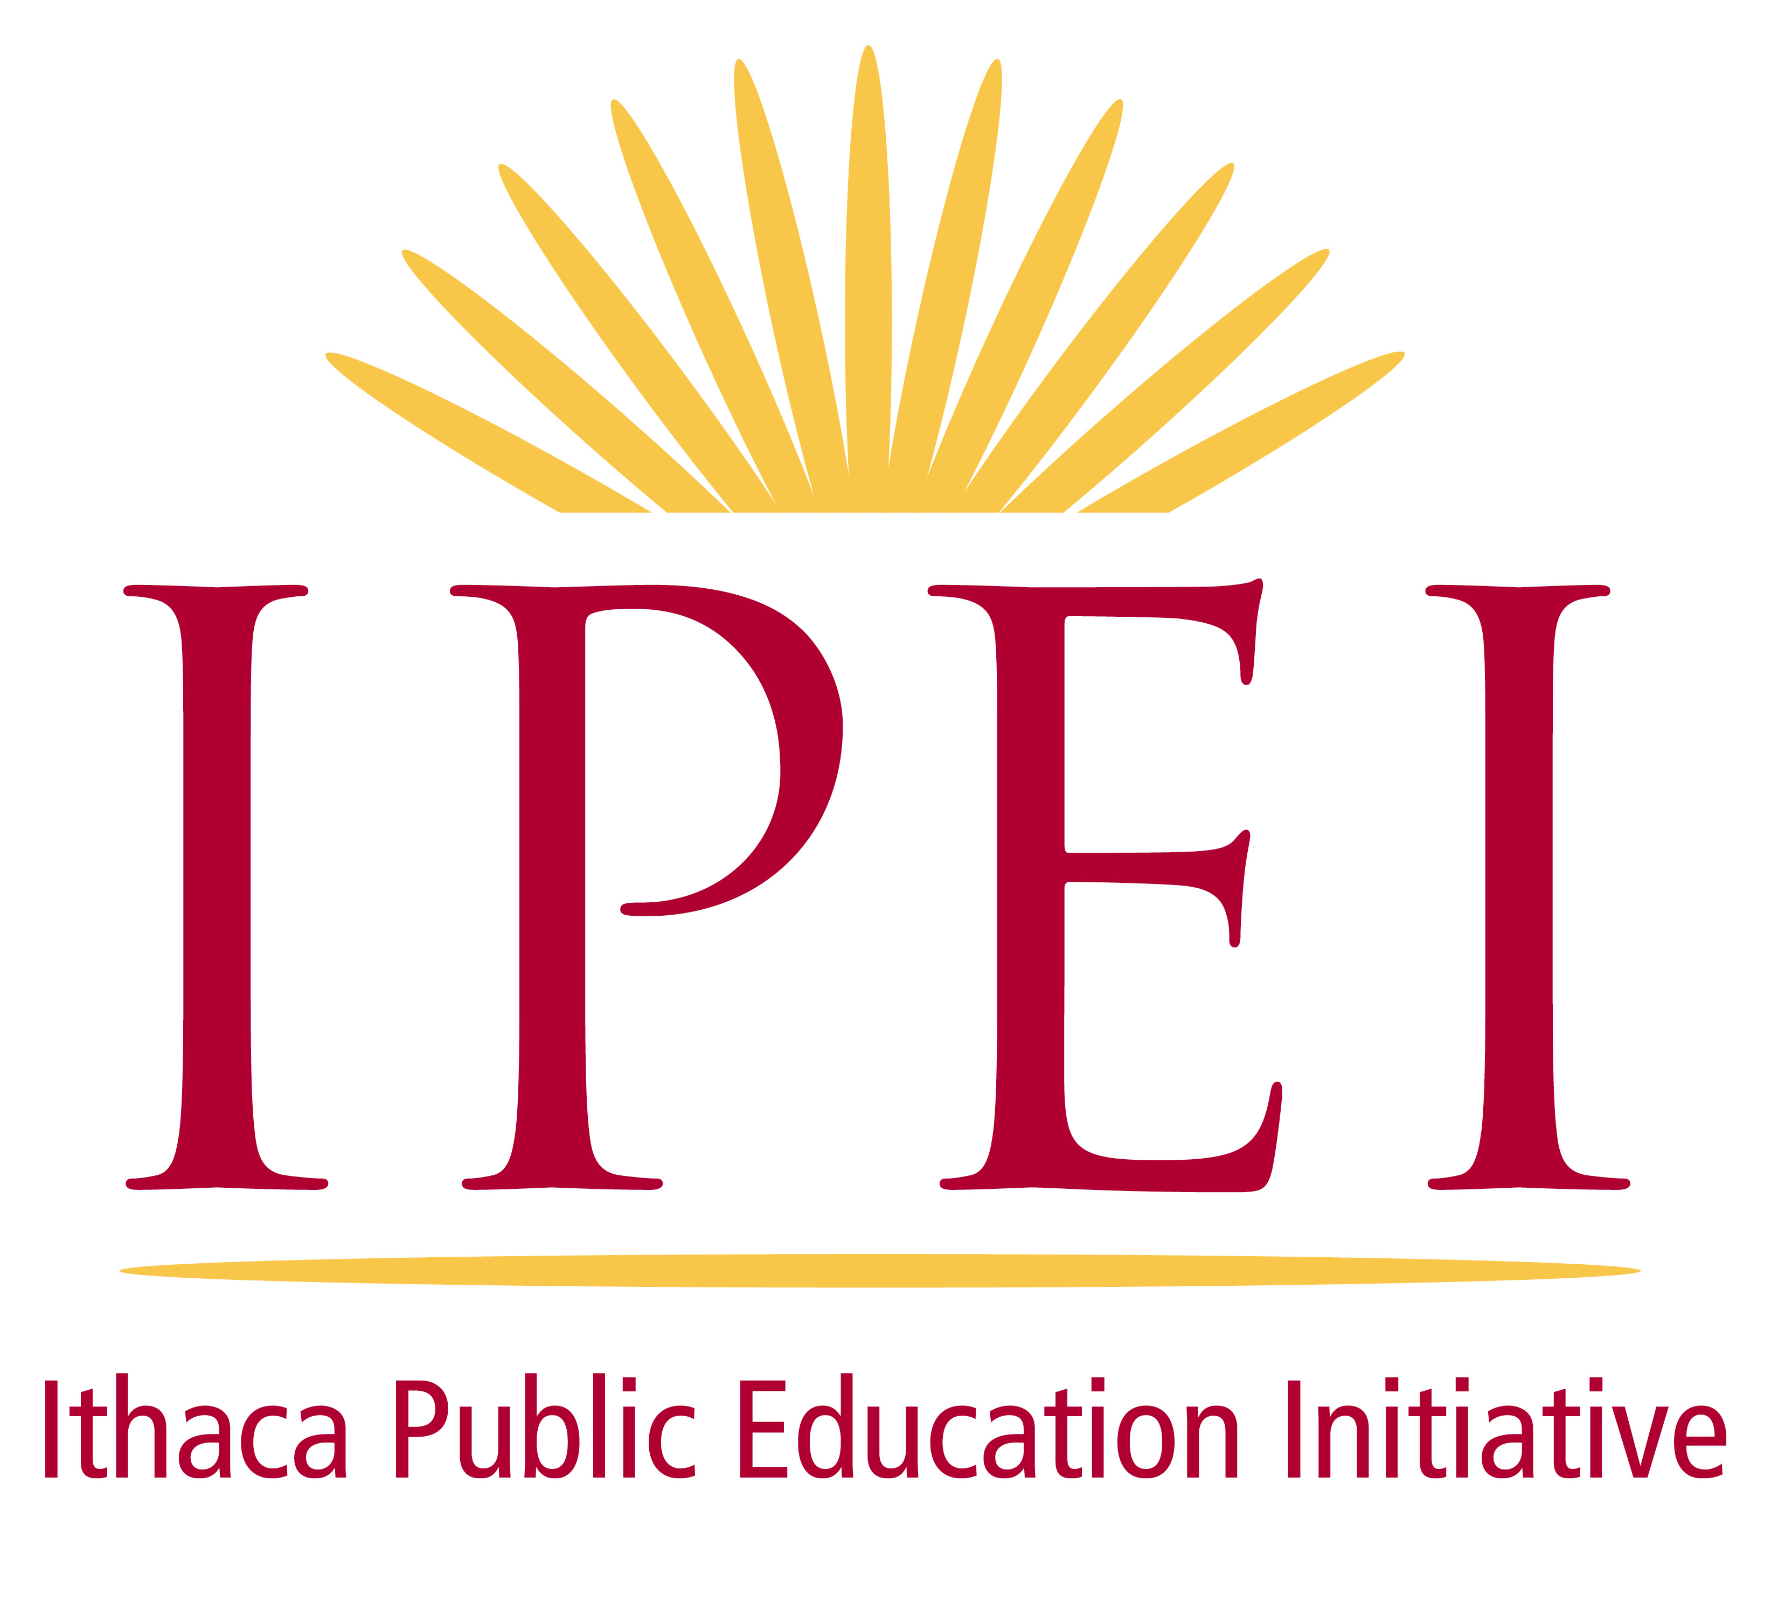
The mission of the Ithaca Public Education Initiative (IPEI) is to facilitate community connections and support for students and teachers of the Ithaca City School District through engagement, collaboration, gifts, and grants. For more information see IPEI.org or contact us at 607-263-IPEI (4734) or ipei@ipei.org.

